Operrwork Microservice

Setup

Guidance DOCUMENT OPERRWORK VERISON -2

|  |  |
| --- | --- |
| Created by | Bao Pham |
| Date | 15-Jan-2021 |
| Version | 1.0 |

**CHANGELOGS:**

|  |  |  |  |
| --- | --- | --- | --- |
| Reviewer | Date | Version | Comments |
| Ngô Xuân Thuấn | 07-Nov-2021 | 1.0 | Initial Version |

Table of Contents

**Backend setup** 2

**Requirements:** 2

**BUILD:** 2

**RUN:** 3

**Fontend Setup** 4

**Requirements:** 4

**Overview:** 4

**BUILD:** 4

**RUN:** 4

**Screen shoot** 4

# **Backend setup**

## **Requirements:**

* Java JDK/JRE 8
* Maven build (latest version)

<https://www.mkyong.com/maven/how-to-install-maven-in-windows/>

* IntelliJ idea.
* Kafka, zookeeper version 2

<https://www.apache.org/dyn/closer.cgi?path=/kafka/2.3.1/kafka_2.11-2.3.1.tgz>

* Install Lombok (<https://projectlombok.org/setup/eclipse> )
* MySQL version 5.6 (root/root)
* Redis: version 3.2

<https://github.com/microsoftarchive/redis/releases/download/win-3.2.100/Redis-x64-3.2.100.msi>

## **BUILD:**

* Import project to Inteliji ide
* Update Maven Project for each service
* Install common service: **mvn clean install**

## **RUN:**

* Run discovery service
* Run config service
* Run gateway service
* Run sso service
* Run inventory service
* Run payment service

Success screen

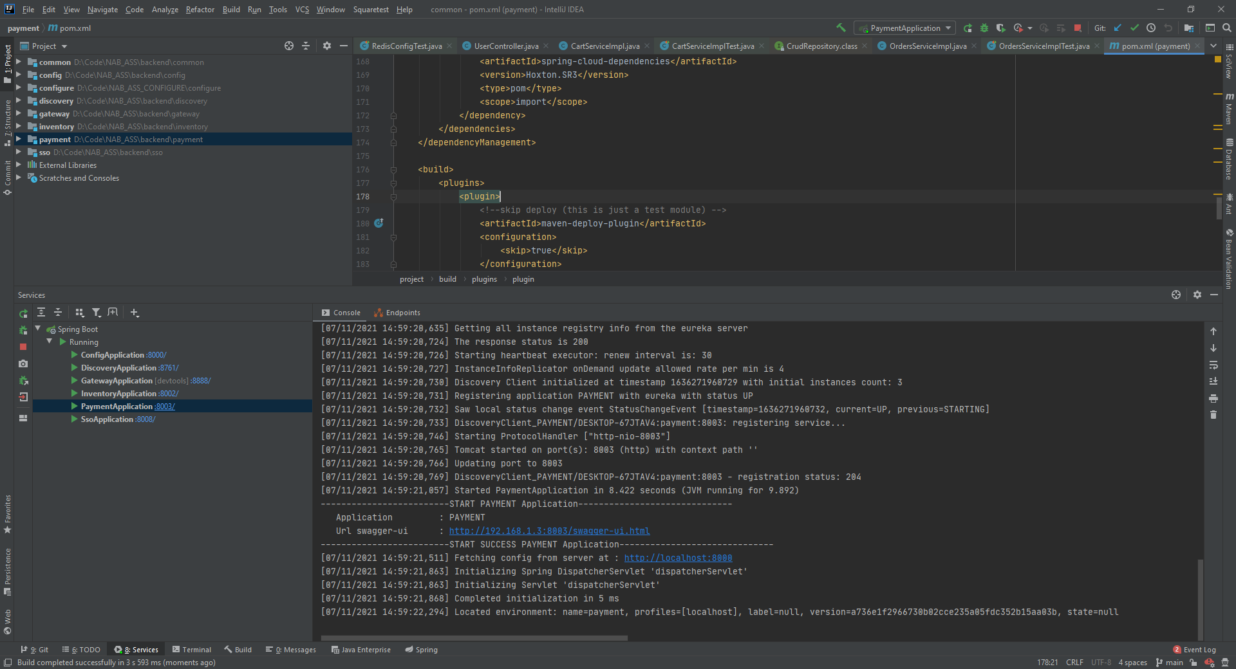

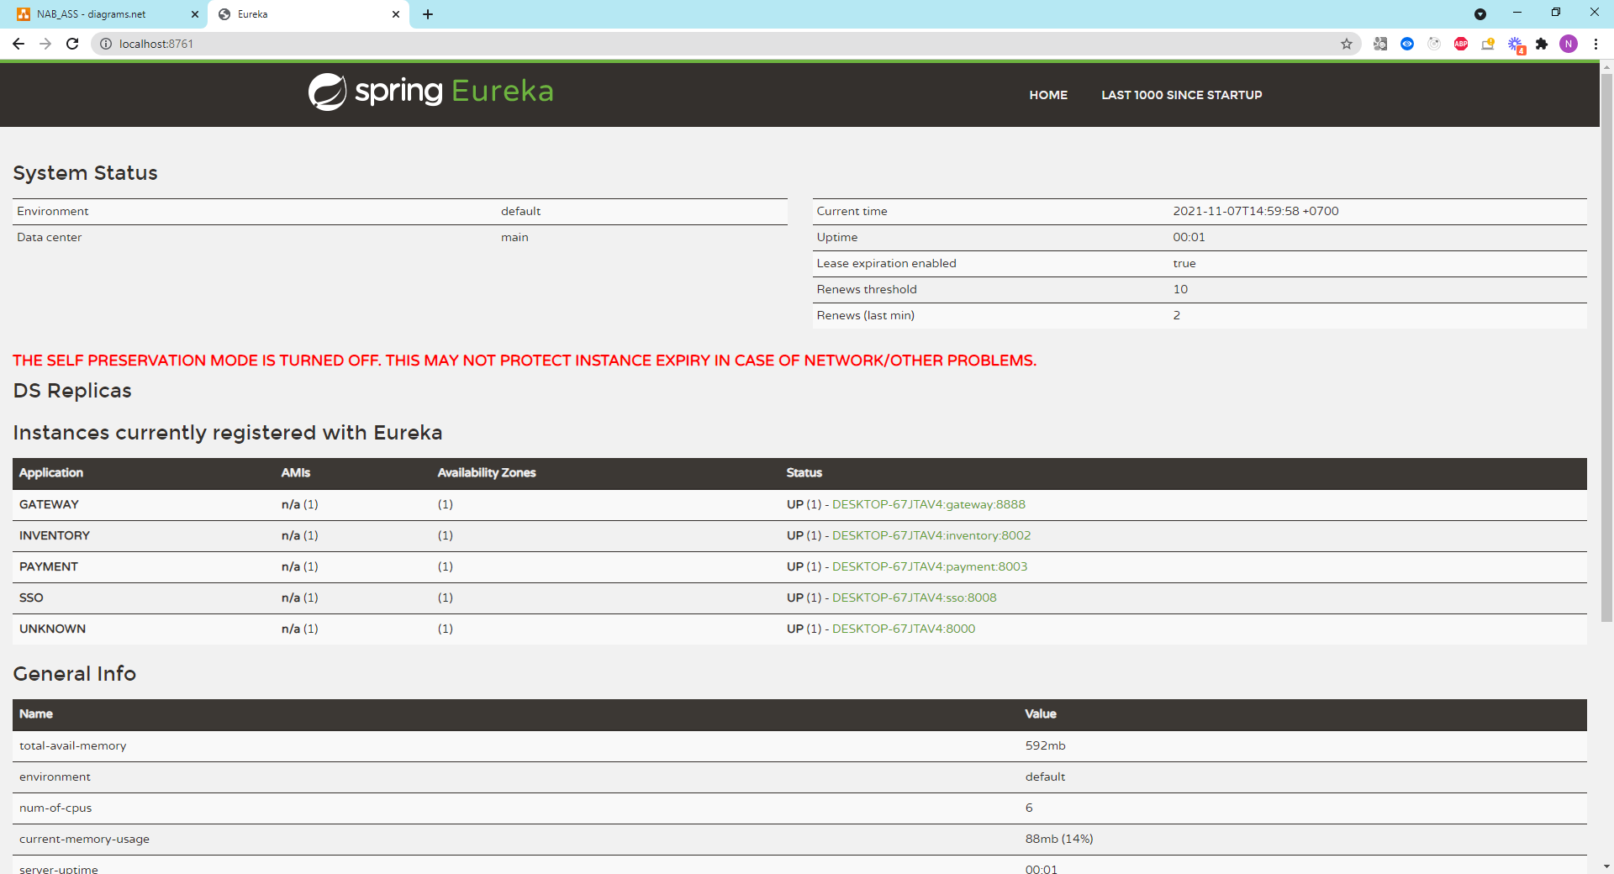

# 

# **Fontend Setup**

## **Requirements:**

* NodeJS (latest version)
* Inteliji ide

## **Overview:**

- Local site <http://localhost:4200/>

## **BUILD:**

* Run **npm install**

## **RUN:**

* Run **ng start**

## **Screen shoot**

